PYTHON ESSENTIALS
CHAPTER 1:- Thinking like a programmer
The key learning objectives of this chapter are:-
- Understanding the significance of programing skills in today’s digital age.
- Recognizing python as a versatile and beginner-friendly programming language.
- Understanding programmatic thinking and apply it to everyday situations.
- Utilizing pseudocode and flowcharts to plan and visualize algorithms.
Common phrases that you may see include:-
- READ, OBTAIN, or GET for inputs.
- PRINT , DISPLAY, or SHOW for outputs.
- COMPUTE, CALCULATE, or DETERMINE for calculations.
- SET or INIT for setting values.
- INCREMENT or BUMP for increasing a value by one, a common process.
Pseudocode and Flowcharts :-
- Pseudocode and Flowcharts form a powerful duo for problem-solving and algorithm design.
- They enable programmers plan their solutions methodically, breaking down complex problems into manageable steps.
CHAPTER 2 :-Getting started with python
The key learning objectives of this chapter are:-
- Understanding the general syntax of python.
- Utilizing functions such as print(), input(), and type().
- Understanding and utilizing data types and variables.
- Using conditional logic to branch code.
- Understanding and utilizing the different types of loops in python.
Data Types (Build in functions in python):-
- Integer – int()
- Float – float()
- String – str()
- Boolean values – bool()
In python , 0 is false and 1 is true.
Conditional Statements:-
- if() :- it’s a conditional statement used for decision-making in Python.
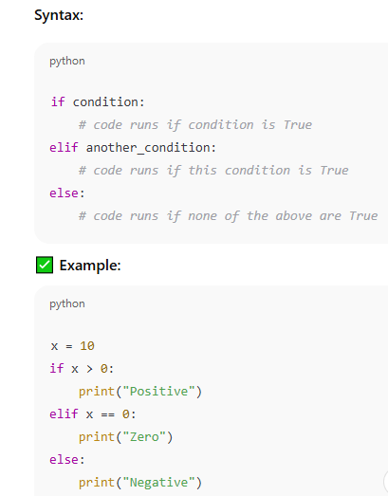
- nested if():- A nested if means putting one if statement inside another if — it’s used when you need to check multiple conditions in sequence.
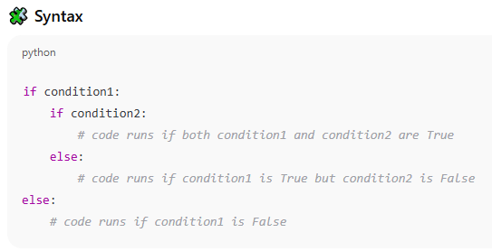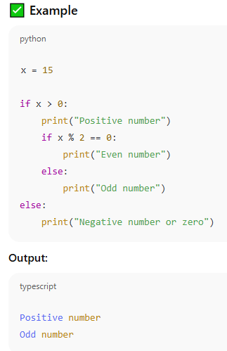

- for loop() :- In Python, a for loop is used to repeat (iterate) over a sequence — like a list, tuple, string, or range of numbers.
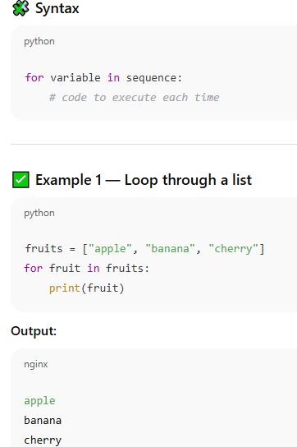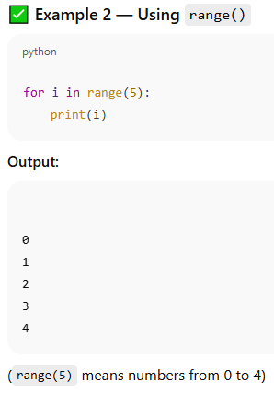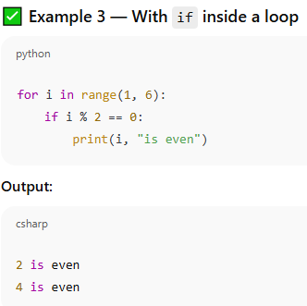

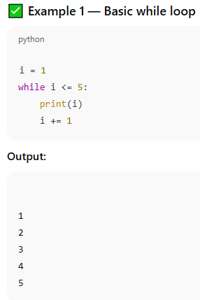
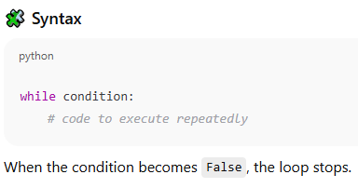
- while loop() :- A while loop keeps running while the condition is True — use it when you don’t know in advance how many times the loop should run.

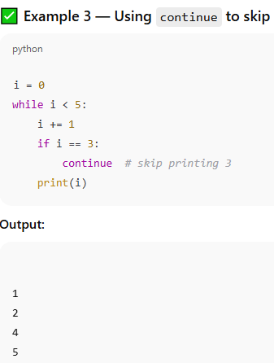
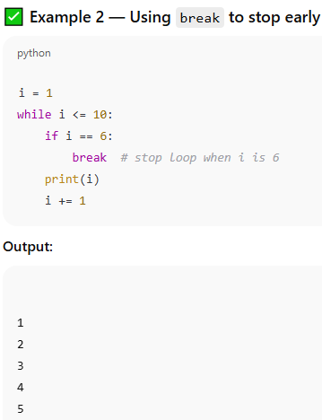
Comparison Symbols:-
- > (Greater than)
- >= (Greater than or equal to)
- < (Less than)
- <= (Less than or equal to)
- == (Equal to)
- != (Not equal to)
A Logical truth table:-
a | b | a and b | a or b | not a | Not b
True | True | True | True | False | False
True | False | False | True | False | True
False | True | False | True | True | False
False | False | False | False | True | False

CHAPTER 3 :- Data structures in python
The key learning objectives of this chapter are:-
- Understand the difference between lists, tuples, sets, and dictionaries.
- Create and modify the various data structures.
- Use methods associated with accessing and modifying data structures.

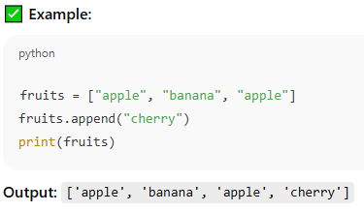
1. List — Ordered & Changeable
- Syntax: [ ]
- Allows duplicates
- Mutable (can change elements)
- Ordered (keeps insertion order)

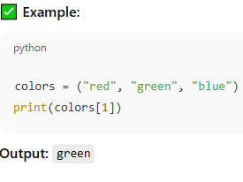
2. Tuple — Ordered & Unchangeable
- Syntax: ( )
- Allows duplicates
- Immutable (cannot modify after creation)
- Ordered

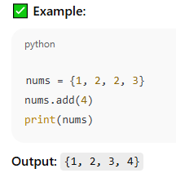
3. Set — Unordered & Unique
- Syntax: { }
- No duplicates allowed
- Unordered (no index positions)
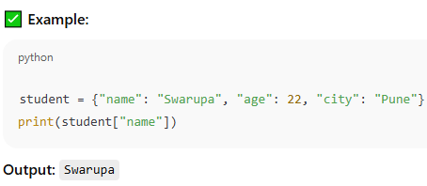
- Mutable (can add/remove items, but not change existing ones)

4. Dictionary — Key–Value Pairs
- Syntax: {key: value}
- No duplicate keys
- Ordered (Python 3.7+)
- Mutable

CHAPTER 4 :- Functions and modular programming
The key learning objectives of this chapter are:-
  - Importing functions from python libraries.
  - Utilizing PIP to install third-party libraries.
  - Writing our own functions .
  - Understanding functions and variable scope.
  - Working with modules and packages.

1. What is a Function?

A function is a block of reusable code that performs a specific task.
It helps you avoid repetition, makes code organized, and easy to maintain.

Types of Functions
- Built-in → e.g. print(), len(), sum()
- User-defined → you create them using def
- Lambda (anonymous) → short one-line functions

2. Modular Programming

Modular programming means splitting your code into separate, smaller modules (files) — each with a specific purpose.
It makes your code:

Easier to debug

Easier to reuse

Easier to maintain
Concept | Meaning | Purpose
Function | A block of reusable code | To perform a specific task
Module | A file containing Python code (functions, variables, classes) | To organize code logically
Modular Programming | Dividing code into modules | To make large programs manageable and reusable

Build-in Libraries:-
- Math:- provides extra mathematical functions and constants.
- Random:- provides functions for creating random numbers and randomizing events.
- Datetime:- provides functions for working with dates , times, and time intervals.
- Os:- provides functions for interacting with the operation system, most often files and directories.
Importing everything from a library:-
 | Import Random | From Random Import*
Getting a random integer | Random.randint(1,10) | Radint(1,10)
Getting a random list item | Random.choice ([‘apples’, ‘bananas’, ‘cherries’]) | choice ([‘apples’, ‘bananas’, ‘cherries’])

Third party libraries include:-
- NumPy:- provides function for complex mathematical computations working with arrays.
- Pandas:- provides functions for working with data sets.
- Matplotlib:- provides functions for data visualization and plots.
- Requests:- provides functions for sending HTTP requests and working with web APIs.
- Beautiful Soup:- provides functions for web scraping.
CHAPTER 5 :- Object-Oriented Programming
The key learning objectives of this chapter are:-
  - Understanding the core concepts of object-oriented programming.
  - Creating and Using classes and objects.
  - Applying inheritance and composition to our classes.
  - Understanding how to encapsulate data and control access from outside classes.
- OOP is a programming style where we design code using objects — real-world entities that have data (attributes) and behavior (methods).
- It helps make code more organized, reusable, and easier to maintain.
Core Concepts of OOP in Python:-
Concept | Meaning | Example
Class | A blueprint or template for objects | class Car:
Object | An instance of a class | my_car = Car()
Attributes | Variables that hold data about the object | self.color, self.speed
Methods | Functions that define object behavior | drive(), brake()
Inheritance | Reusing features of an existing class | class ElectricCar(Car)
Encapsulation | Hiding internal details | Using private variables (_speed)
Polymorphism | Same method name, different behavior | move() for Car and Plane

Procedural Programming vs Object-Oriented Programming:-
Procedural Programming | Object-Oriented Programming
Code is organized into functions. | Code is organized into classes.
Functions promote reusability. | Techniques such as inheritance and polymorphism enhance reusability.
Data and functions are separate. | Data and functions are bundled together.
Suitable for small to medium size programs. | Better for larger, more complex systems.

Printing with Variables:-
Comma separated arguments | Name = “Jimmy”  Print(“Hello”, name) | Only works within print function
Concatenated strings | Name = “Jimmy”  Print(“Hello” + name) | Only works within string
F-strings | Name = “Jimmy”  Print(f “Hello { name}”) | Starts with “f” Variables wrapped with curly brackets and inside quotations.

CHAPTER 6 :- Error Handling and Exceptions
The key learning objectives of this chapter are:-
  - Understanding the information being given in an error report.
  - Understanding some of the basic error types.
  - Using try-except blocks to handle errors without crashes.
  - Raising exceptions in problem situations.
  - Writing custom exceptions when built-in functions area not suitable.

- Errors are problems that stop your program from running correctly.
In Python, most errors that happen while running code are called Exceptions.

Most common python errors and exceptuions:-
Error Name | When It Happens | Example | Fix / Explanation
SyntaxError | Code structure is invalid | if x > 5 print(x) | Missing : → should be if x > 5: print(x)
IndentationError | Incorrect indentation (spacing) | print("Hi") print("Hello") | Keep consistent spaces/tabs
NameError | Variable or function not defined | print(age) | Define it first: age = 10
TypeError | Wrong data type used in an operation | "2" + 3 | Convert properly: int("2") + 3
ValueError | Invalid value for a data type | int("hello") | Ensure correct value: int("10")
ZeroDivisionError | Dividing by zero | 10 / 0 | Check denominator before dividing
IndexError | Index out of range in list or tuple | my_list[5] (list has only 3 elements) | Use valid index: my_list[0] to my_list[2]
KeyError | Accessing a missing dictionary key | data["age"] (key doesn’t exist) | Use data.get("age") instead
AttributeError | Using a method that doesn’t exist | x = 5; x.append(2) | Make sure object supports the method
ImportError | Importing missing or wrong module | import maths | Correct spelling: import math
FileNotFoundError | Trying to open a missing file | open("data.txt") (file not found) | Check file path or use try/except
ModuleNotFoundError | Importing a module that isn’t installed | import pandasx | Correct name or install with pip install pandas
RuntimeError | Generic error during execution | Rare — depends on logic | Fix logic or data handling
RecursionError | Function calls itself too many times | Infinite recursive calls | Add a stop condition
MemoryError | System runs out of memory | Creating a huge list | Optimize or use batch processing
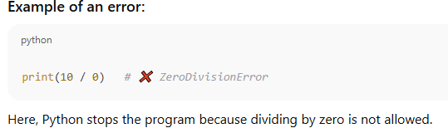

Handling Exceptions with try and except:-

We use try-except blocks to catch and handle errors instead of letting the program crash.
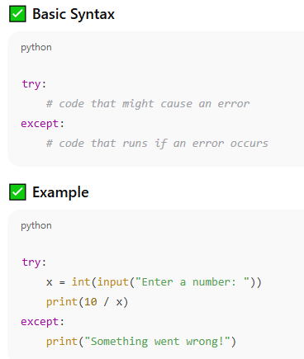

Handling Specific Exceptions:-

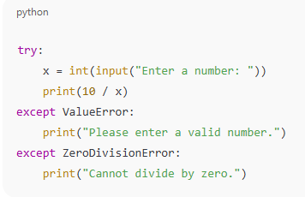
You can catch different types of errors separately.

Common Python Exceptions:-
Exception | Description
ZeroDivisionError | Dividing by zero
ValueError | Invalid value type
TypeError | Wrong data type used
IndexError | Index out of range
KeyError | Missing dictionary key
FileNotFoundError | File not found
ImportError | Importing missing module

CHAPTER 7 :- A Practical Guide for Working Professinals
The key learning objectives of this chapter are:-
  - Understanding the importance of data in making decisions.
  - Loading, cleaning, and analysing data with Pandas.
  - Creating visualizations with Matplotlib.
Data is the core of modern decision-making — in business, healthcare, education, finance, etc.
Why data matters:-
- Helps make evidence-based decisions instead of guessing.
- Identifies trends and patterns.
- Measures performance and progress.
- Predicts future outcomes using analytics and AI.Loading, Cleaning, and Analyzing Data with Pandas:-
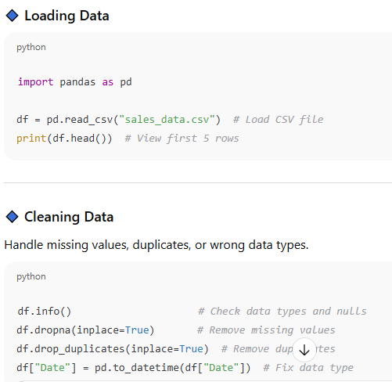
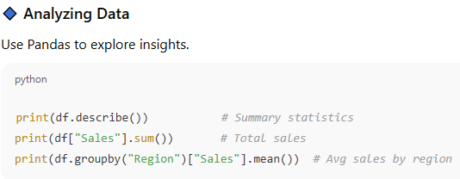
Pandas is Python’s most popular library for working with structured data (like Excel or CSV files).
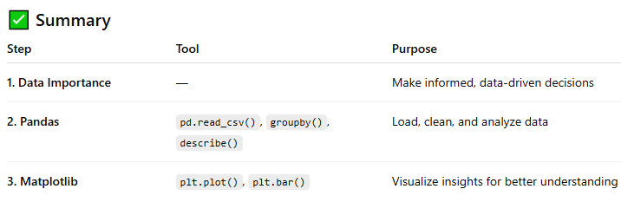
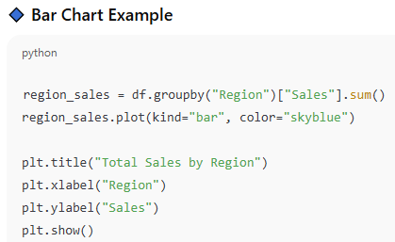
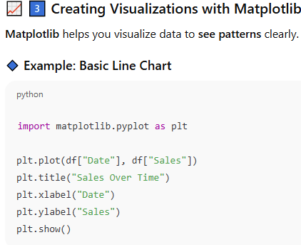
Useful matplotlib.pyplot functions:-
Function | Meaning / Purpose | Example
plt.figure() | Creates a new figure/window for plotting | plt.figure(figsize=(8,5))
plt.title() | Adds a title to the chart | plt.title("Monthly Sales Report")
plt.xlabel() | Adds a label to the X-axis | plt.xlabel("Month")
plt.ylabel() | Adds a label to the Y-axis | plt.ylabel("Revenue")
plt.plot() | Draws a line graph | plt.plot(x, y)
plt.scatter() | Draws a scatter plot | plt.scatter(x, y)
plt.bar() | Draws a vertical bar chart | plt.bar(x, height)
plt.barh() | Draws a horizontal bar chart | plt.barh(y, width)
plt.hist() | Creates a histogram (for frequency data) | plt.hist(data, bins=10)
plt.pie() | Creates a pie chart | plt.pie(values, labels=labels)
plt.boxplot() | Creates a box-and-whisker plot | plt.boxplot(data)
plt.grid() | Adds a grid behind the chart | plt.grid(True)
plt.legend() | Shows a legend (labels for lines or bars) | plt.legend(["2024", "2025"])
plt.xlim() | Sets the range for X-axis | plt.xlim(0, 100)
plt.ylim() | Sets the range for Y-axis | plt.ylim(0, 500)
plt.xticks() | Customizes X-axis tick marks or rotation | plt.xticks(rotation=45)
plt.yticks() | Customizes Y-axis tick marks | plt.yticks(fontsize=12)
plt.text() | Adds text at specific (x, y) position | plt.text(2, 10, "Peak")
plt.annotate() | Adds arrows and notes | plt.annotate("Max", xy=(3,20), xytext=(4,25), arrowprops=dict(arrowstyle="->"))
plt.subplot() | Creates multiple plots in one figure | plt.subplot(2,1,1)
plt.subplots() | Creates multiple axes objects easily | fig, ax = plt.subplots(2,2)
plt.tight_layout() | Adjusts spacing to avoid overlap | plt.tight_layout()
plt.savefig() | Saves the plot as an image file | plt.savefig("chart.png")
plt.show() | Displays the plot window | plt.show()

CHAPTER 8:- Case Studies
The key learning objectives of this chapter are:-
- Understanding how to approach real-word applications.
- Exploring how to use different techniques to approach problems.
- Gaining experience in working with datasets.

CHAPTER 9:- EXPLORING Emerging Trends in Programming
The key learning objectives of this chapter are:-
- Understanding the fundamental concepts of artificial intelligence and machine learning.
- Understanding how python can interface with real-word devices.
- Understanding the principles of web scraping.
- Understanding how frameworks like Flask and Django can create dynamic websites.
- Understanding the role of cloud computing in modern applications.

Artificial Intelligence (AI) & Machine Learning (ML):-

What it means:

AI: Making computers think and act like humans (e.g., speech recognition, decision-making).

ML: A part of AI where machines learn from data instead of being explicitly programmed.

Example:

AI: A chatbot that understands and replies intelligently.

ML: Predicting house prices using past data.

Python Tools:

scikit-learn → for training models

tensorflow / pytorch → for deep learning

pandas & numpy → for data preprocessing

Python Interfacing with Real-World Devices:-

What it means:

Python can interact with hardware and sensors — used in IoT (Internet of Things) and automation.

Example:

Reading temperature from a sensor on a Raspberry Pi.

Controlling LEDs, motors, or cameras using Python.

Python Libraries:

pySerial → communicate with Arduino boards

RPi.GPIO → control Raspberry Pi pins

socket → for network-based device control

Web Scraping
What it means:
Web scraping is the process of extracting data from websites automatically.
Example:
- Collecting product prices from e-commerce sites.
- Fetching live weather data from a weather website.

Python Libraries:

requests → download web pages

BeautifulSoup → parse HTML

selenium → automate browsers (for dynamic sites)

Flask and Django (Dynamic Websites):-

What it means:

Frameworks like Flask and Django help you create web applications using Python.
Framework | Type | Best For
Flask | Lightweight | Small projects, APIs
Django | Full-featured | Large, database-driven websites

Cloud Computing in Modern Applications:-

What it means:

Cloud computing allows you to store, run, and scale your applications on remote servers (instead of your local machine). Example:

Hosting a Flask app on AWS or Google Cloud.

Using Microsoft Azure for ML model deployment.

Storing big data on Google Drive or AWS S3.

Popular Cloud Platforms:

AWS (Amazon Web Services)

Microsoft Azure

Google Cloud Platform (GCP)

CHAPTER 10:- Next Steps and Further Resources
The key learning objectives of this chapter are:-
- Identifying how to set goals and routines to build programming habits.
- Identifying opportunities to practice programming.
- Exploring career paths for programmers.
- Identifying essential tools and resources to assist in programming.

